**CZ1003**

**Mini Project Report**

Real-time Canteen Information System

**Done By:**

Srishti

Bernard Koh

Chew Kit Waye Andrel

**Group FS5**

**Contents**

**Objective** 3

**Introduction** 3

**Algorithm Design** 3

**Flow Chart** 4

**Storyboard** 5

**Database Handling** 6

**Graphical User Interfaces and User Defined Functions** 7

**Start of the Application** 7

**Option 1. Display the stall information based on current system date and time** 8

**Then is followed by displaying menu available from the selected stall based on current system date and time** 9

**Option 2. Pick a date and time from application’s calendar, which then display the stall information based on user defined date and time** 10

**Then is followed by displaying menu available from the selected stall based on user defined system date and time** 12

**After selecting a stall, user can then input the number of people queueing to estimate their waiting time before their turn** 13

13

**The user can also check operating hours from the selected stall page** 14

**Program Testing** 15

**Error Handling** 15

**Reflection** 19

**Contribution** 19

# **Objective**

The objective of this report is to describe the work flow, algorithm and program testing of our application.

# **Introduction**

NTU’s north spine canteen is a popular choice for students to have a quick meal in between breaks during school. In order to enhance the experience of individuals willing to dine in the canteen, we have created a real-time canteen information system. With this application, users will be allowed to browse through the stalls open in the north spine canteen and their current menu at any date and time. It also helps to determine the waiting time for each stall to help the user make informed decisions.

Designed using Python 3.8 and Tkinter, this program makes use of a dynamic program involving two files, strings, dictionaries, lists and tuples. The dynamic program enables changes made in the database to be reflected immediately in the application.

# **Algorithm Design**

For algorithm design is divided into a few sections. The sections are as following: Flow chart, Thought Process, Database Handling, Graphical User Interfaces and User Defined Functions.

## **Flow Chart**

First and foremost, a flow chart is crafted to identify and organise the way how our application will work. This help us to have a better understanding while programming our application down the road.

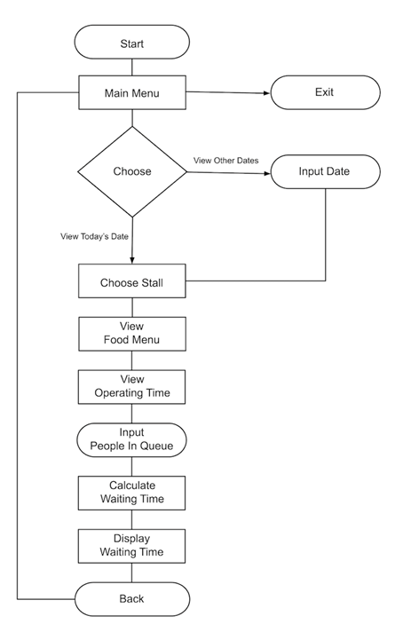

## **Storyboard**

We created a storyboard so that each one of us could visualize our program while designing and coding.

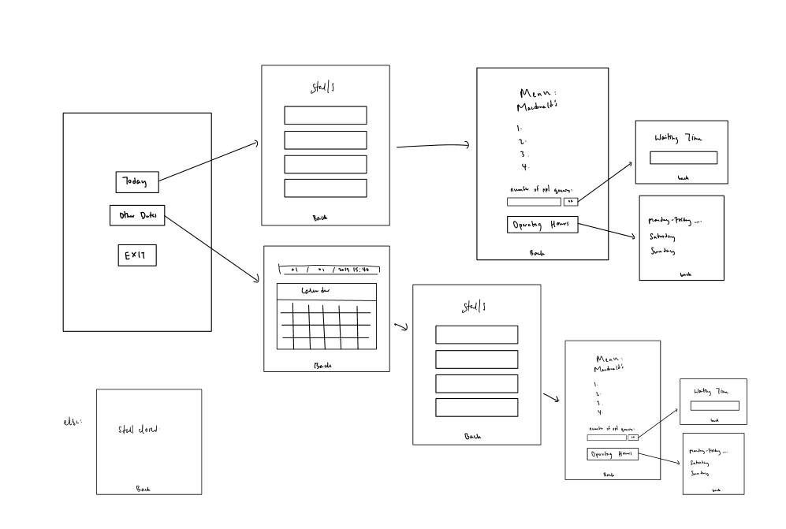

## **Database Handling**

Secondly, we planned and designed a database for our application that stored the values of each stalls and their menu. Thus, we came up with the two following objects:

**Stall**

|  |  |  |  |  |
| --- | --- | --- | --- | --- |
| Stall Key | Stall Name | Opening Hours | Closing Hours | Waiting Time |

.

**Menu**

|  |  |  |  |  |  |
| --- | --- | --- | --- | --- | --- |
| Menu Name | Stall Key | Available Day | Start Time | End Time | Price |

We had included a “Stall Key” in order to “inner join” stall and menu so that a stall can have many menu items, but a menu item only belong to a stall.

## **Graphical User Interfaces and User Defined Functions**

### **Start of the Application**

Option 1, the user is greeted by the application. There will be 2 available buttons for users to press; “View Today’s Stall” and “View Stall by Date”.

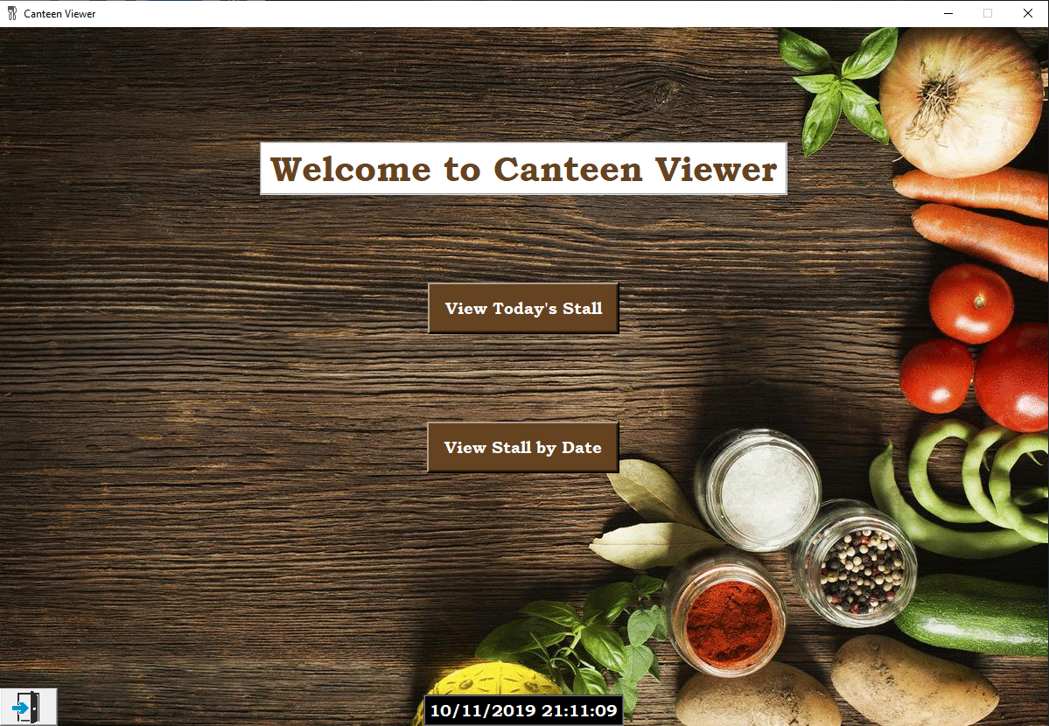

**2**

**1**

**4**

**3**

1. “View Today’s Stall” button to view available stall today. (Based on system date and time)
2. “View Stall by Date” button to pick a date and time to find out the stall available on that day.
3. Displayed system time.
4. Exit button to exit the application.

### **Option 1. Display the stall information based on current system date and time**

“View Today’s Stall” button is clicked.

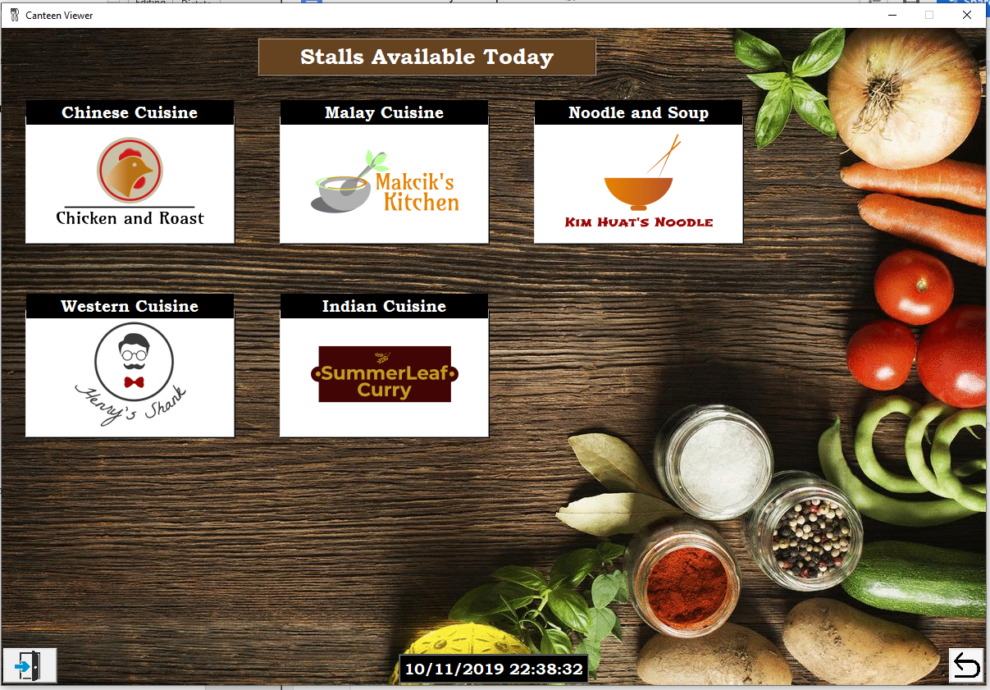

**2**

**1**

1. Individual Stall’s name and their logo. When pressed, the menu items belong to the stall will be displayed.
2. Every page beside the starting page have a back button, to return to the previous page.

### **Then is followed by displaying menu available from the selected stall based on current system date and time**

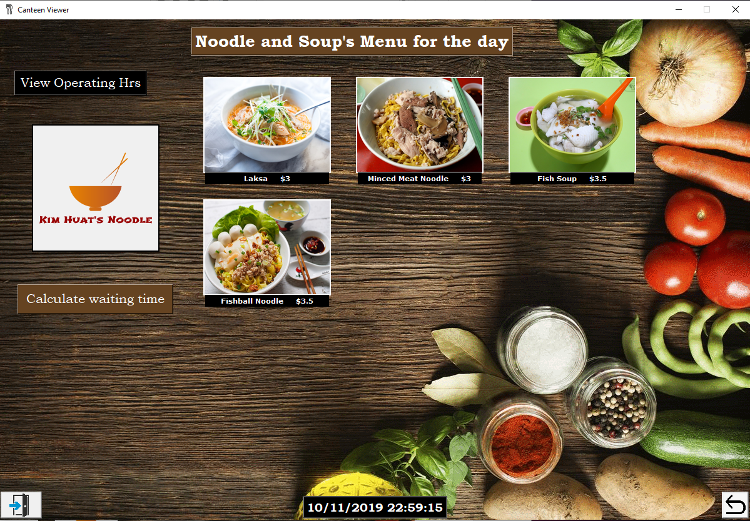

**2**

**1**

1. Selected stall’s logo.
2. Each menu item and its name and price.

### **Option 2. Pick a date and time from application’s calendar, which then display the stall information based on user defined date and time**

“View Stall by Date” button is clicked.

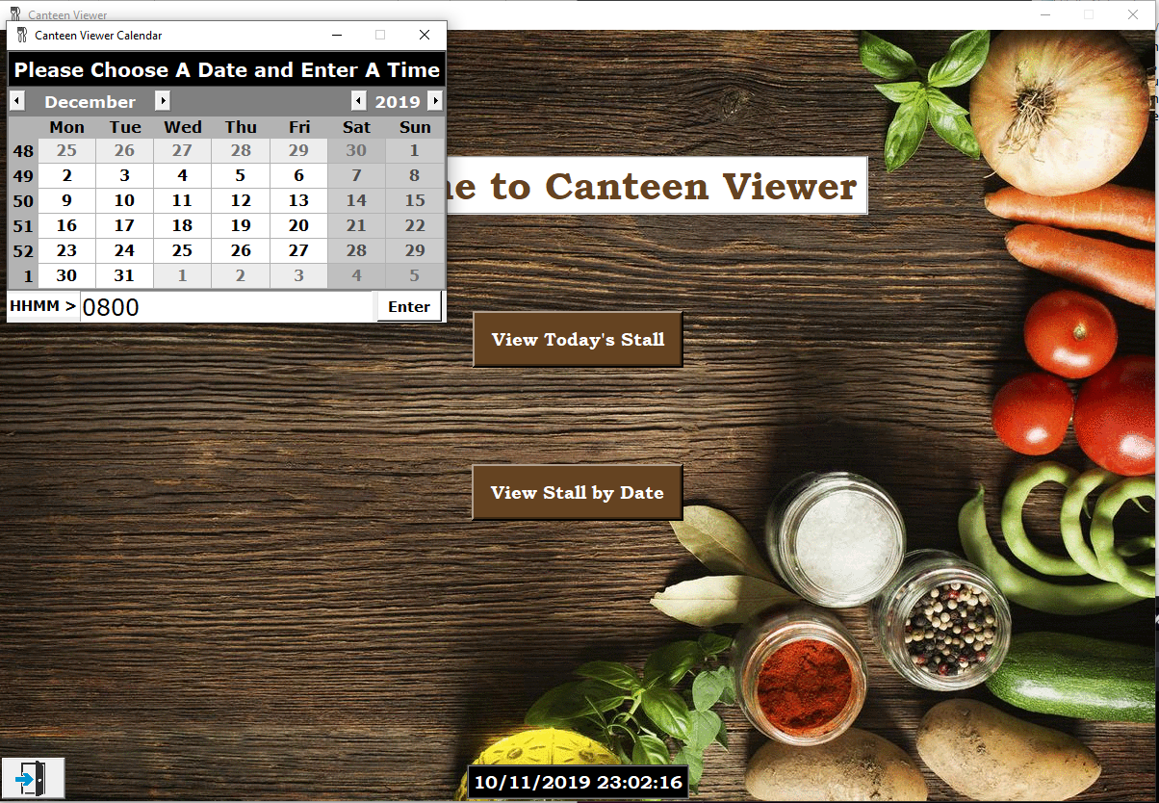

**2**

**1**

1. Application’s calendar picker.
2. User entry for time.

Then we are shown the stalls available on user selected date.

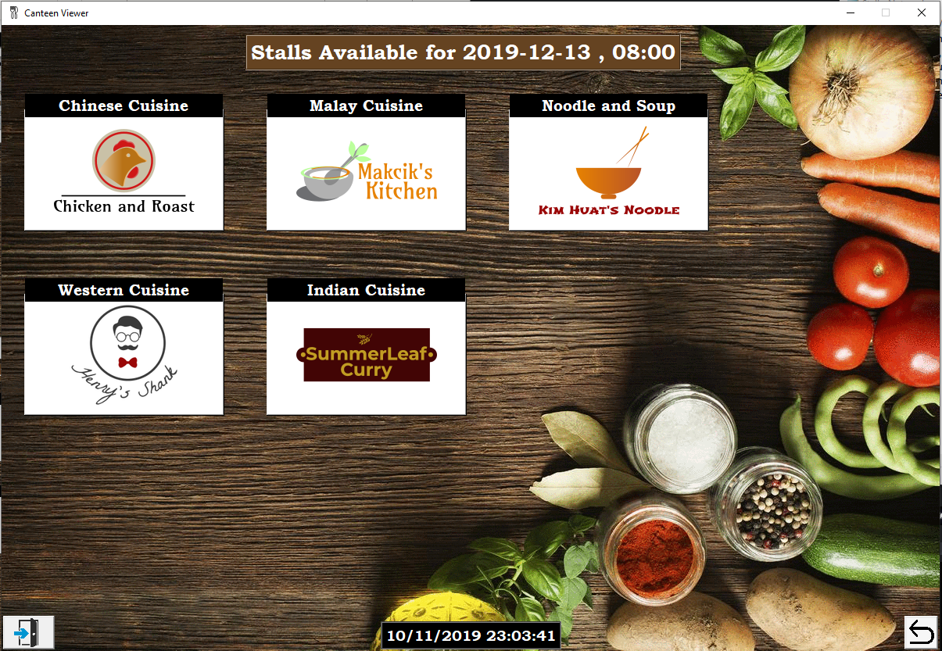

**1**

1. Individual Stall’s name and their logo. When pressed, the menu items belong to the stall will be displayed.

### **Then is followed by displaying menu available from the selected stall based on user defined system date and time**

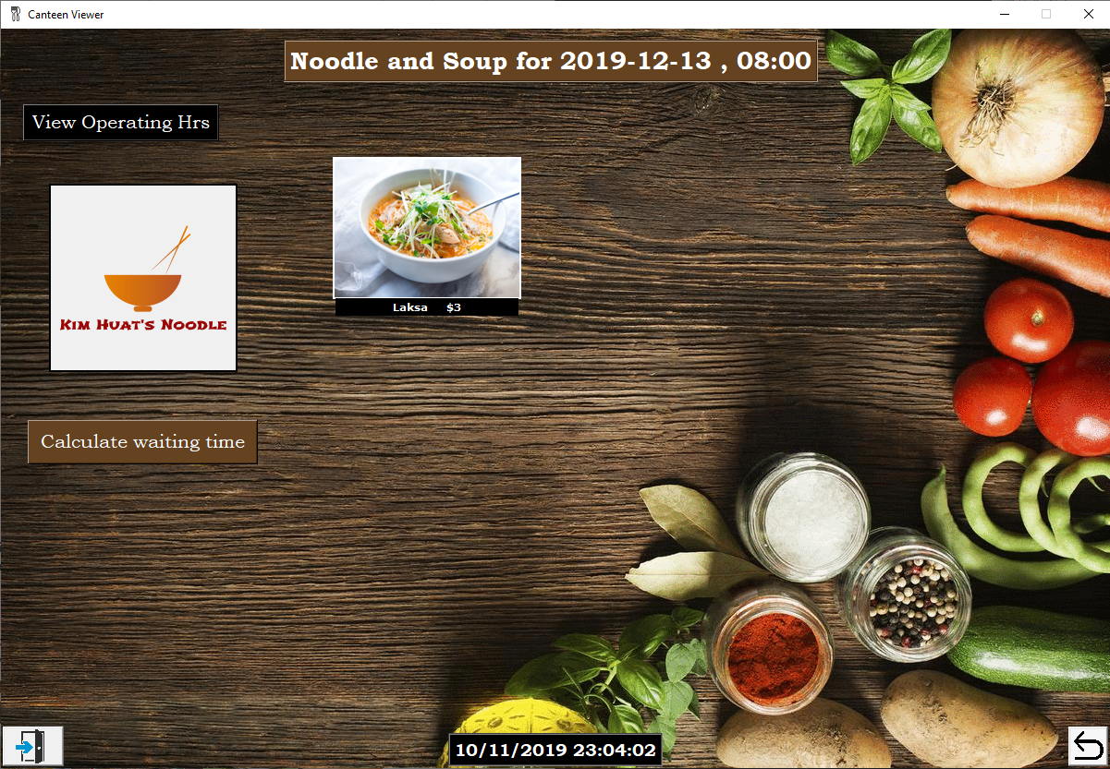

**1**

**2**

1. Selected stall’s logo.
2. Each menu item and its name and price.

### **After selecting a stall, user can then input the number of people queueing to estimate their waiting time before their turn**

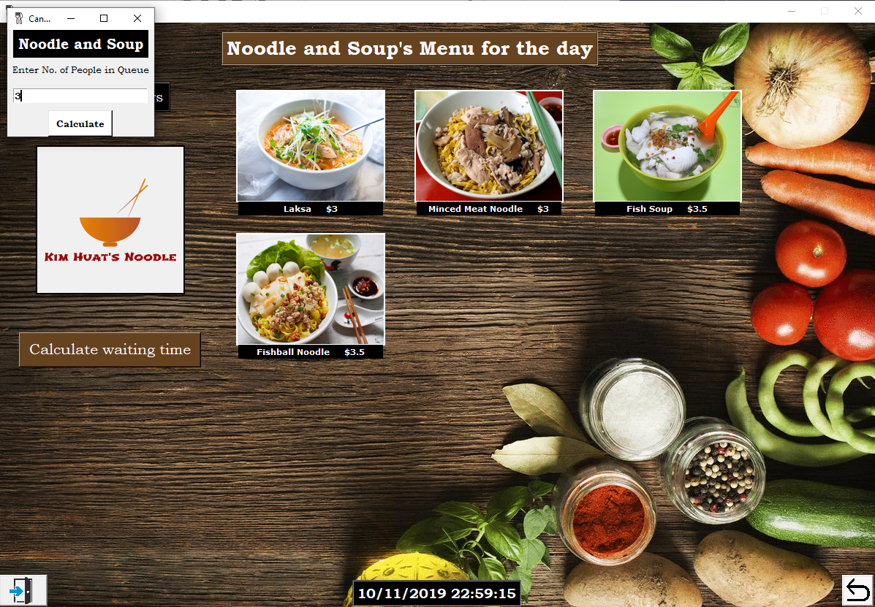

**1**

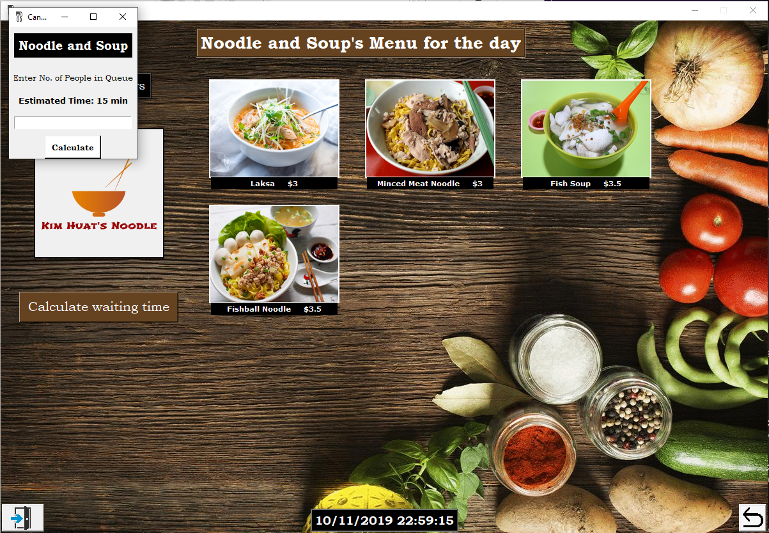

**1**

### **The user can also check operating hours from the selected stall page**



**1**

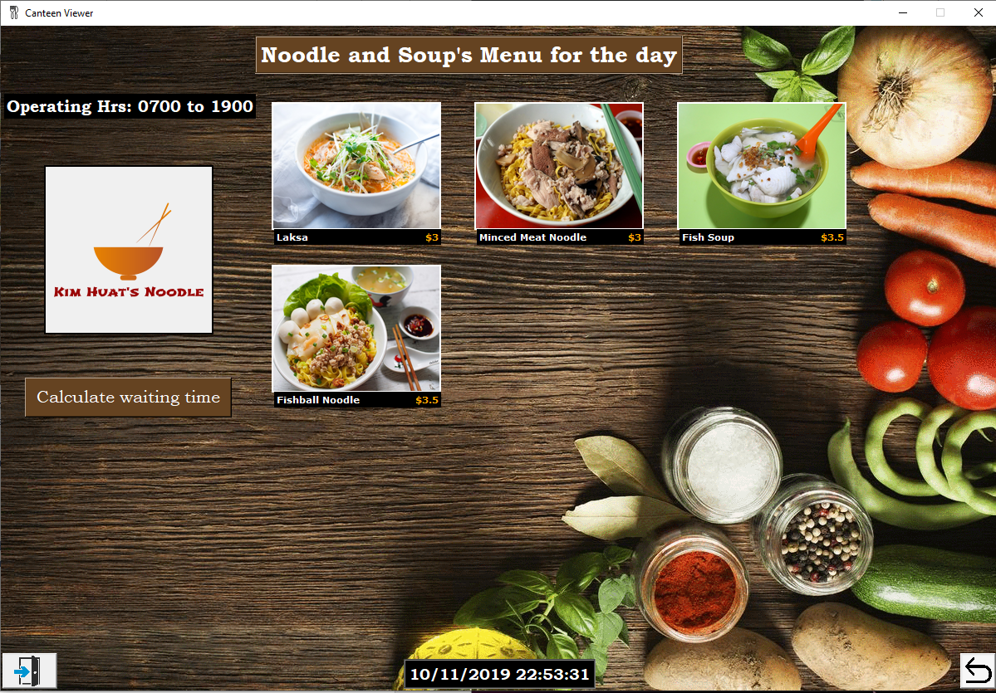

**1**

# **Program Testing**

## **Error Handling**

1. **When there is no food available currently or based on user’s selected date, the following message will be shown.**

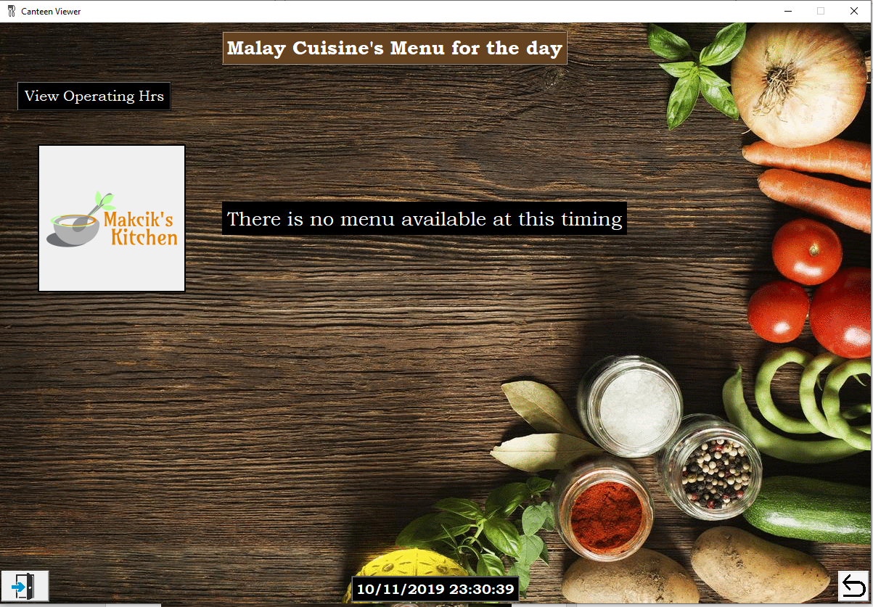

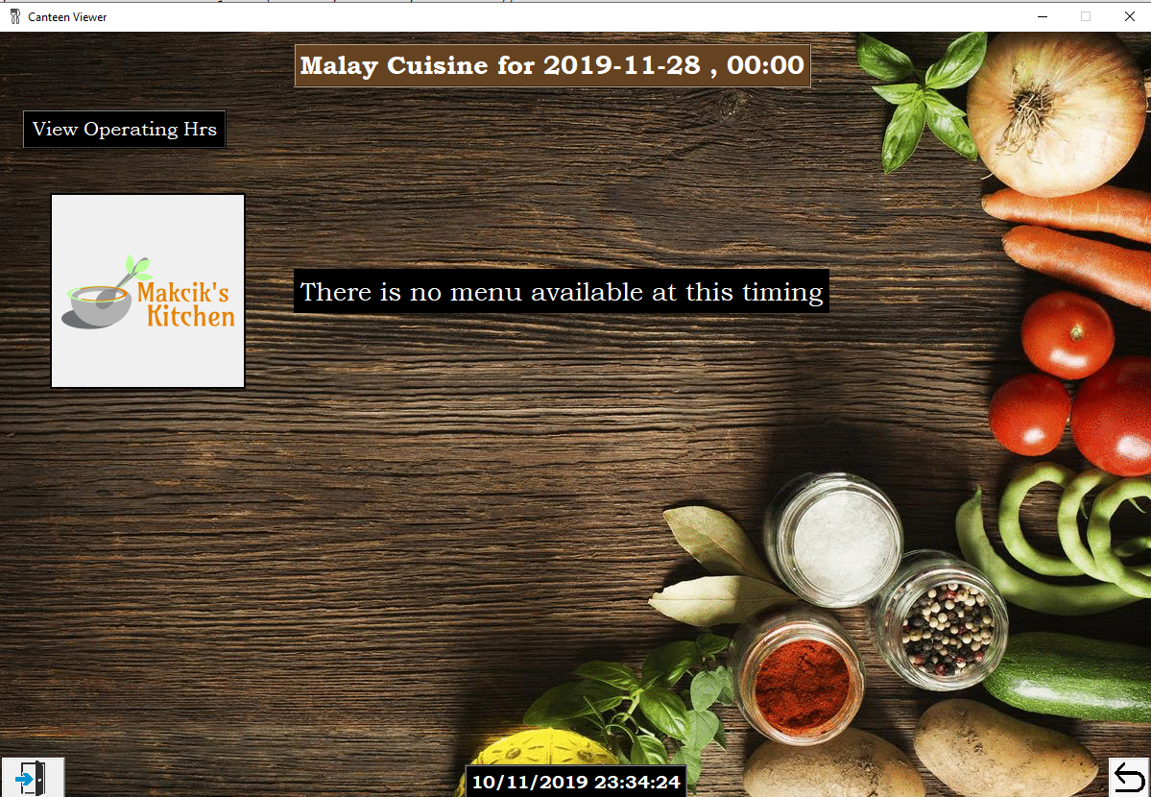

1. **When user input number of people in the queue:**

1st Scenario: Not all number Result:

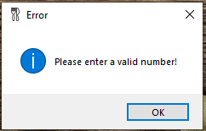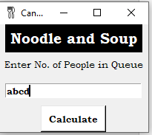

2nd Scenario: Number more than 20 Result:

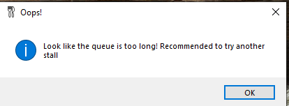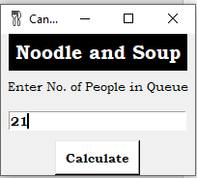

1. **Input time to view stalls and menus based on selected date and time:**

1st Scenario: Not all number

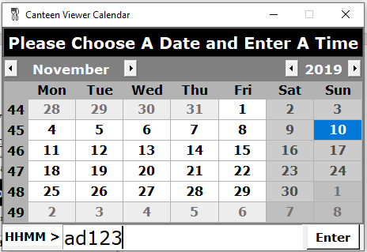

Result:

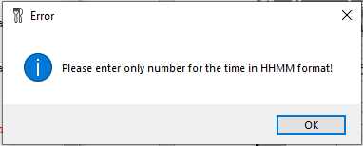

2nd Scenario: Not within 0000 to 2359, or not 4 digits in the format of HHMM

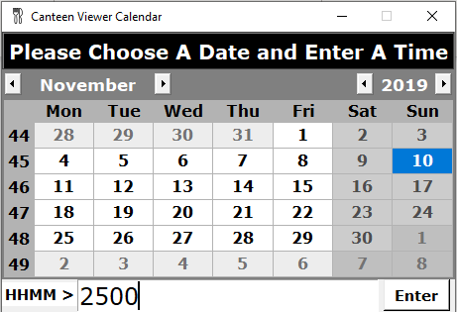

Result:

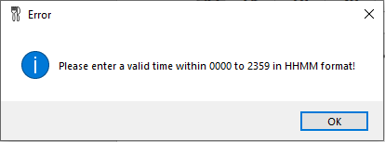

# **Reflection**

Through this project, we learnt the usefulness of modular programming. By using modular programming, we were able to code more efficiently so that one could design and code out the GUI while the other could design functions to be called from the GUI.

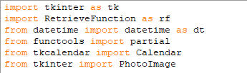

For example, we used RetrieveFunction.py as our function module separated from our GUI file.

We also learnt the importance of planning the flow chart and have a good sense of what your program will do before diving into the coding. Having a strong sense of what your strategy you are going to implement, will make coding much more efficient and goal driven. Things like database handling, storyboard should be crafted beforehand. Further, we learnt how to program dynamically and how this method could prevent redundancy of code.

Most importantly, the project has been a great experience. Teamwork is crucial in any form of project and good communication is key. We learnt to better converse our ideas with our group mates. We can complement our individual skills together, thus bringing out the best we can. Without prior python programming experience, all of us have met with difficulties in the coding segment, more so when tasked with GUI designing for python. However, we were able to help coop through with the help of lectures and lab sessions which improved on our problem-solving skills. In all, this has been an enriching and memorable project to kickstart our first year in NTU.

# **Contribution**

Stall and menu data handling – Bernard

Calendar and GUI – Srishti

Waiting time and operating hours – Andrel

Report and Slides – All